GenAI Testing

Various models of genai
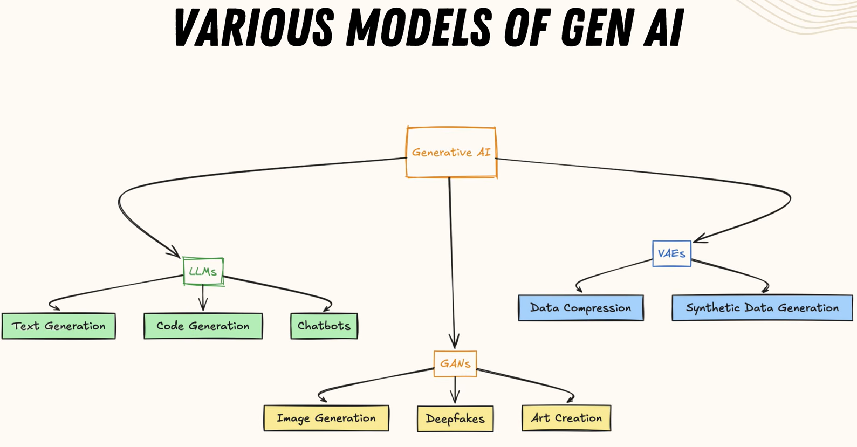
- Large Langauge Model (LLM)
- Variational Autoencoder (VAE)
- Generative Adversarial Network

Applications for software testing with genai
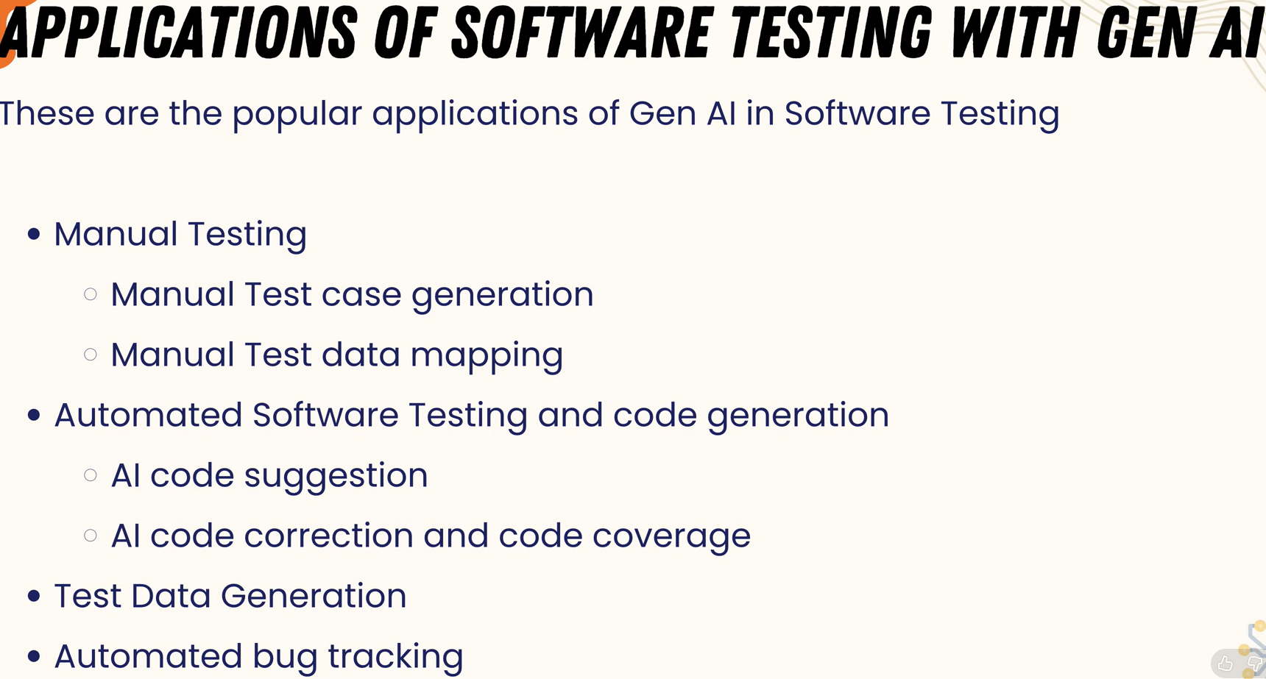

How companies use LLM’s ?
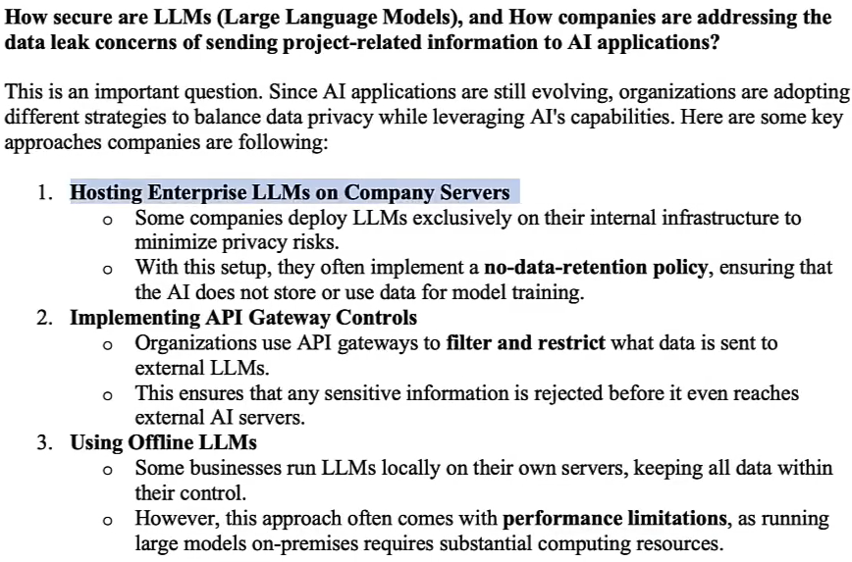

There Are 3 Ways GenAI Is Implemented in Testing

1. AI as an Assistant (Most Common Today)
- This is NOT a framework.
- This is:
  - Using OpenAI / Gemini / Claude
  - Inside IDE
  - Inside CI
  - Inside custom scripts
- Example:
  - Developer writes Jira story
  - Script sends story to LLM API
  - LLM returns test cases
  - Developer reviews
  - Playwright executes
- Here, GenAI is integrated manually using API.
- No special “AI testing framework”.
- Just LLM + existing automation.
- AI-as-assistant does NOT automatically monitor your project.
- It works only when you:
  - Prompt it
  - Paste logs
  - Ask for fixes
  - Ask for new test generation

2. AI-Enhanced Testing Platforms (Actual Products)
- There ARE AI-based testing tools.
- AI is embedded inside the automation tool to improve reliability, maintenance, and stability — but humans still define what to test.
- Focus : Making automation smarter and more stable.
- Examples:
  - Mabl
  - Testim
  - Functionize
  - Applitools
- Primary Focus:
  - Record user flows
  - Use AI to generate locators
  - Self-heal broken selectors
  - Use ML for visual testing
  - Detect layout shifts
  - Reduce flaky failures
- Secondary Focus : generated test-cases and scripts, they can be llm/ human generated
- These are commercial AI-driven testing frameworks.
- Under the hood:
They still use browser automation engines.
- But they add AI layer on top.
- AI Layer
⬇
Playwright/Selenium (hidden internally)
⬇
Browser
- So here:
  - Playwright/Selenium = Engine
  - AI = Smart maintenance + self-healing layer

3. New GenAI-Native Tools (Emerging)
- AI-native tools use AI as the primary decision-maker for exploring, generating, and executing test scenarios — with minimal scripting — but still require human oversight.
- Some modern startups are building:
  - Natural language → test execution directly
  - AI agents that explore UI
  - Vision-based testing (like GPT + computer vision)
- These tools try to reduce scripting entirely.
- AI behaves like a tester
- You write:
  - "Test login with valid and invalid credentials"
- The system:
  - Opens browser
  - Detects input fields visually
  - Executes scenario
- Still early-stage but evolving fast.
- AI brain
⬇
Automation engine (like Playwright)
⬇
Browser

Summary
1. AI as Assistant
LLM helps humans generate test cases and scripts on demand.
Execution happens via Playwright/Selenium.
No built-in intelligence in automation tool.

2. AI-Enhanced Platform
Automation tool has built-in AI to improve stability, locator healing, visual testing, and flakiness detection.
Humans still define test coverage.

3. AI-Native Tool
AI actively explores the application, generates scenarios, and drives testing decisions with minimal scripting.
Human supervises rather than writes tests.

Some Important terms in gen-ai testing

1. Self-Healing Locators
Problem (Traditional Automation)
You write:
page.click("#login-btn-123")
Developer changes:
id="login-btn-789"
What is this?
Test fails.
Now multiply this across:
- 500 tests
- Weekly UI updates
AI-Enhanced Behavior
AI doesn’t store just:
#login-btn-123
It also stores:
- Button text (“Login”)
- Button role (button)
- Position on page
- Parent container
- Nearby labels
- Historical patterns
- DOM hierarchy
When ID changes:
AI says:
“This element changed, but I found a similar button with text ‘Login’ in the same location.”
Updates locator automatically.

2. Smart Element Detection
Traditional automation relies heavily on:
- ID
- XPath
- CSS selectors
But many modern apps:
- Generate dynamic IDs
- Use React components
- Change DOM frequently
AI-Enhanced Tool
Instead of fragile XPath: //div[3]/div[2]/button
AI understands semantic meaning:
- This is a “Submit Order” button
- Inside Checkout page
- Inside payment form
It prefers:
- Role-based locators
- Text-based locators
- Accessibility attributes

3. Flaky Test Reduction
What is a Flaky Test?
A test that:
- Passes sometimes
- Fails sometimes
- Without code change
Reasons:
- Timing issues
- Slow API
- Animations
- Race conditions
AI-Enhanced Tool
AI analyzes historical runs:
Example:
Test A failed 3 times.
All failures happened:
- When response time > 2 seconds.
AI detects pattern:
“Failure likely due to network latency.”
It may:
- Suggest smarter wait
- Adjust timeout dynamically
- Mark test as unstable

4. Visual Comparisons
Traditional testing checks:
assert page.locator("#price").text == "₹999"
But what about:
- Layout shifts?
- Overlapping elements?
- Broken alignment?
- Missing images?

AI Visual Testing
AI captures screenshot baseline.
Next run:
It compares visually.
Not pixel-by-pixel (too sensitive).
But intelligently:
- Is button misplaced?
- Is element overlapping?
- Is font broken?
- Is color wrong?

5. Test Impact Analysis
Traditional CI:
Run all 2000 tests after every commit.
Slow.
Expensive.
Time-consuming.
AI-Based Impact Analysis
AI analyzes:
- Git diff
- Changed files
- Impacted components
- Dependency graph
Then decides:
Only 120 tests are impacted by this change.
CI runs only relevant tests.

KaneAI - GenAI-native software testing agent built by Lambda Test
- allows testers to create, execute, and maintain automated tests using natural language prompts instead of writing code.
- You can write:
  - Login with valid credentials and verify dashboard loads

Why KaneAI Was Created?
Traditional test automation has three big problems:
- Automation is slow - Writing scripts takes time (selenium, assertions, etc)
- Maintenance is painful - When UI changes, locators break, test fails
- Automation requires coding skill - Most manual testers struggle with language (java, python, etc)

How KaneAI Actually Works (Architecture)
Tester prompt
↓
LLM understanding layer
↓
Test planner
↓
Automation generator
↓
Execution engine
↓
Analysis & debugging

- KaneAI can execute automated tests across browsers, OS, and devices using LambdaTest’s cloud infrastructure. (ex: chrome, safari, etc)

Example Workflow
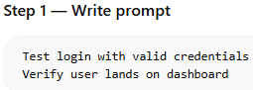
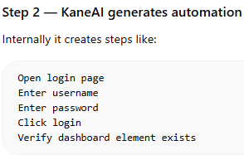
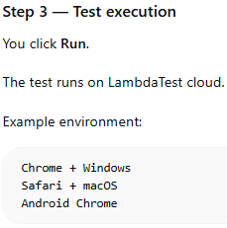
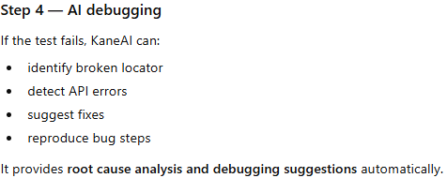
- kane-ai uses HyperExecute is a cloud-based test execution engine.
  - flow :
    - Test scripts → HyperExecute → executes tests in parallel → results

How KaneAI and HyperExecute Work Together?
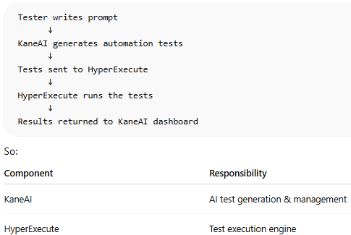

What HyperExecute Actually Runs?
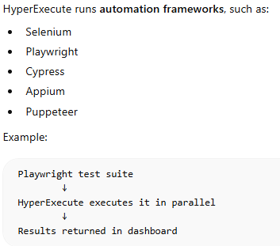

KANE-AI capabilities include:
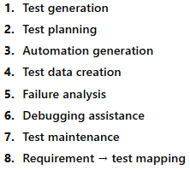
---------------------------------------------------------------------
  - Automation Code Generation :
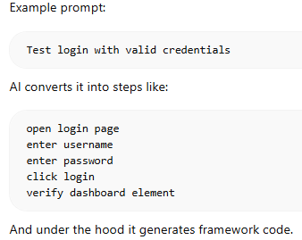
  - Test Data Generation :
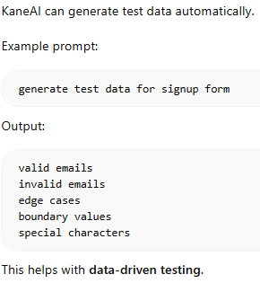
  - Failure Analysis
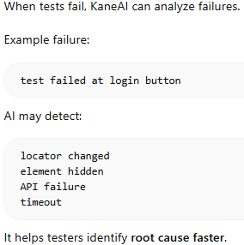

Correct Workflow of KaneAI
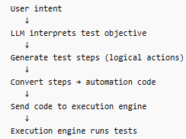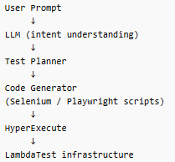

Simplified Architecture
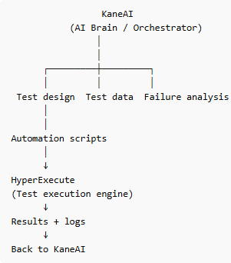

MCP Architecture
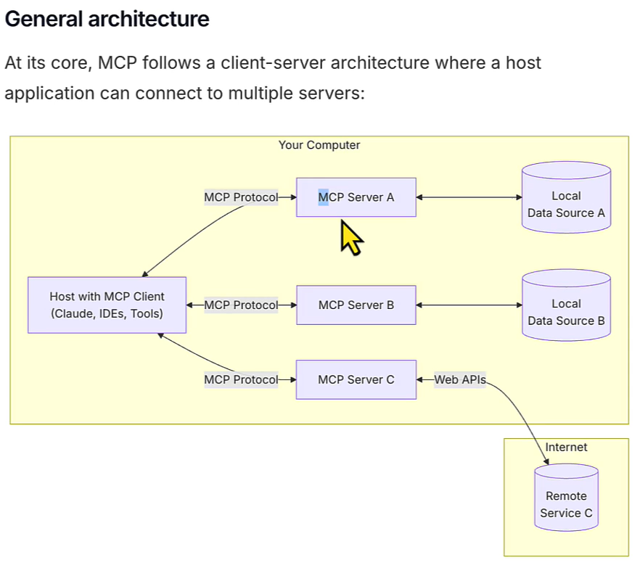
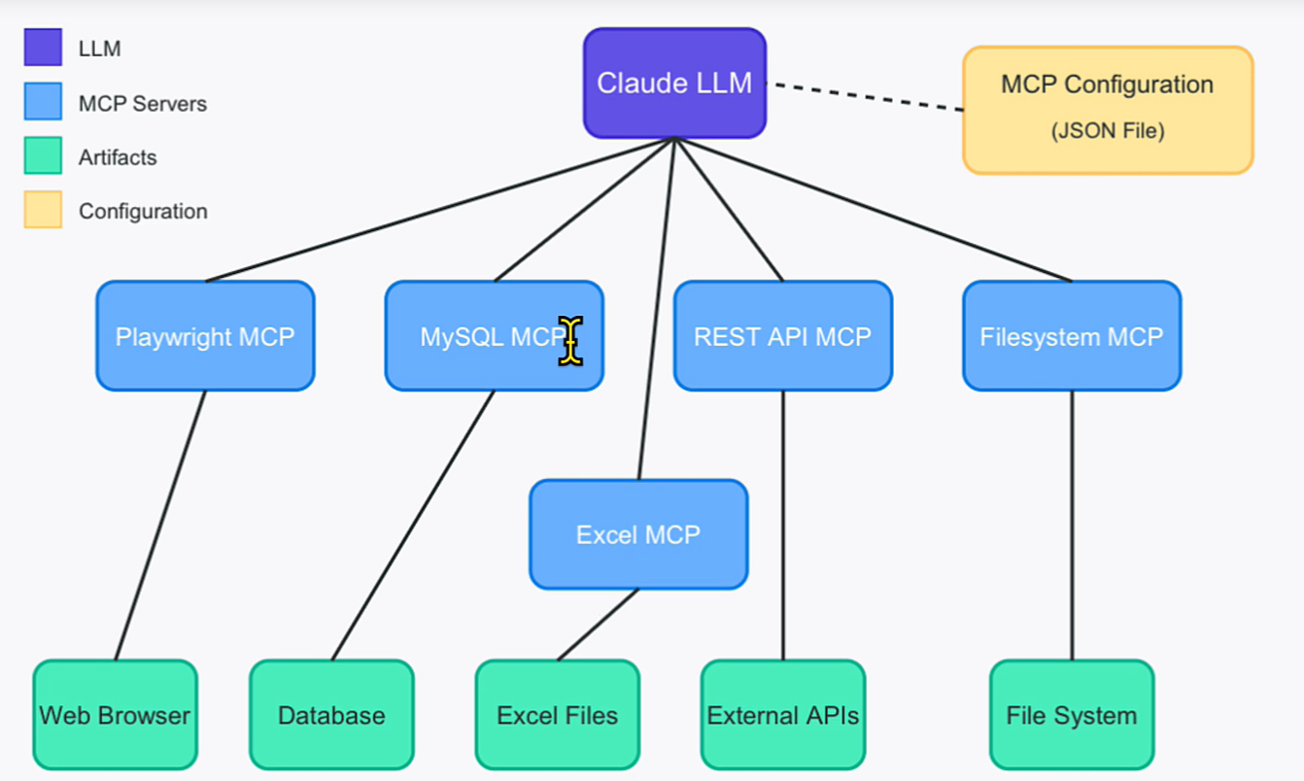

Testing AI itself (LLM)

Gen Ai Testing for Non-GenAI Application

What a Good Research Answer Looks Like
For building a GenAI-driven testing platform, frameworks like LangGraph, CrewAI, and AutoGen can be used to orchestrate AI agents responsible for test planning, generation, execution, and failure analysis. Among these, LangGraph appears most suitable due to its deterministic workflows and production readiness. For parallel agents execution RAY is the best suited tool.

Important Distinction
    - GenAI framework
        - LangGraph
        - CrewAI
        - AutoGen
      - Purpose
        - AI orchestration
    - Testing framework
        - Playwright
        - Selenium
      - Purpose
        - execute tests

Specialized Agents (Per Testing Type)
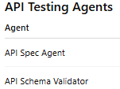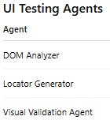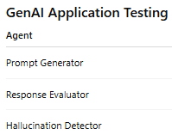

Agents workflow
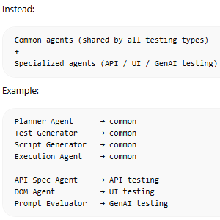

API Testing Workflow
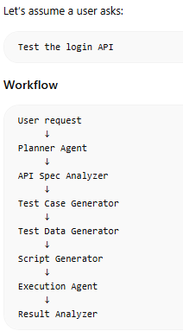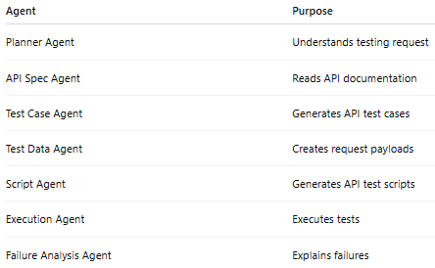

Example API Testing Flow

Step 1 — Planner Agent
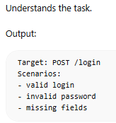

Step 2 — API Spec Agent
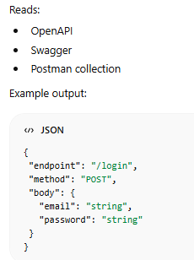

Step 3 — Test Case Agent
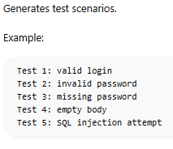

Step 4 — Test Data Agent
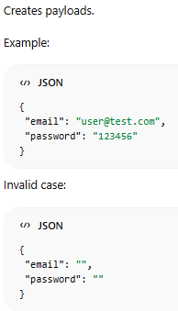

Step 5 — Script Generator Agent
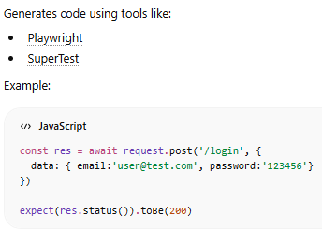

Step 6 — Execution Agent
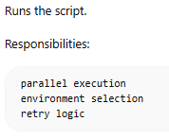

Step 7 — Failure Analysis Agent
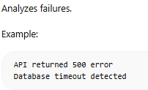

Biggest Challenges in GenAI Testing
- LLM hallucinations - AI may generate incorrect tests.
- Flaky tests - UI tests break due to timing issues.
- Test explosion - AI can generate too many tests.

Final System Architecture (API Testing Only)
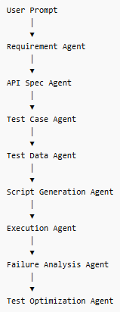

Categories of GenAI Frameworks
Category | Purpose | Example frameworks
LLM application frameworks | basic AI pipelines | LangChain, LlamaIndex
Agent orchestration frameworks | multi-agent systems | LangGraph, CrewAI
Autonomous agent frameworks | fully autonomous agents | AutoGen
Enterprise AI orchestration | scalable production systems | Semantic Kernel

Deep Analysis of Each Framework

1. LangChain
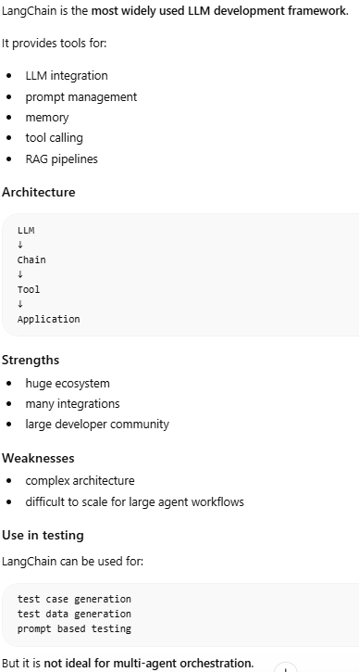

2. LangGraph – Best in all for agents ochestration
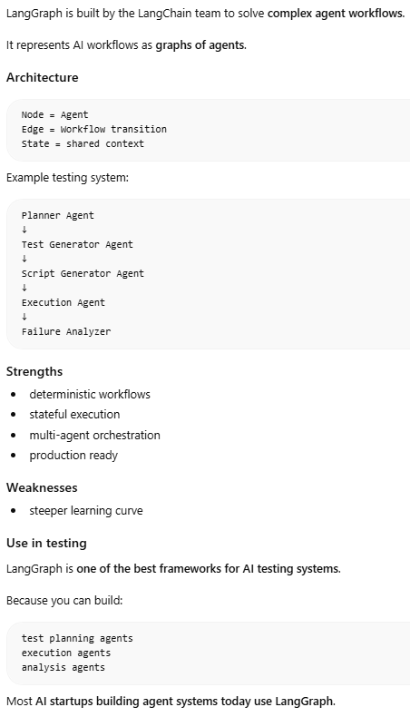

3. CrewAI (Best for structured role-based agents)
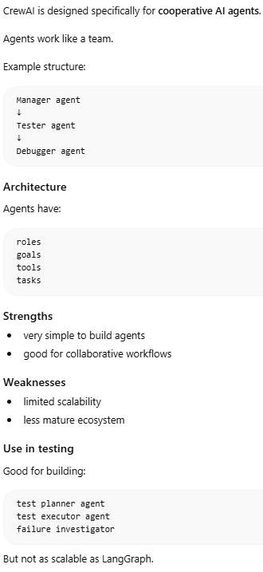

4. AutoGen (Best for research-style multi-agent collaboration)
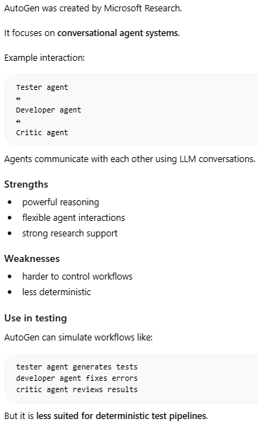

5. LlamaIndex
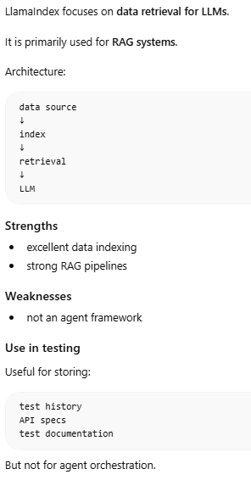

6. Semantic Kernel
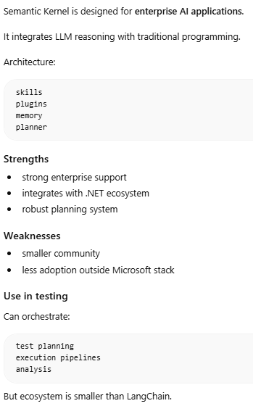

Recommended Architecture for AI Testing
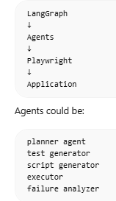

Typical LangGraph Multi-Agent Stack
- Agent orchestration – LangGraph
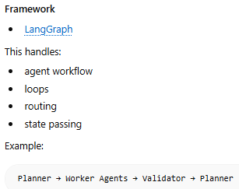
- LLM provider – OpenAi, Anthropic
- Memory layer
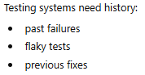
Common tools:
    - Redis → short-term state
    - PostgreSQL → structured storage
    - Pinecone → vector memory
    - Weaviate → semantic search
- Distributed execution – Ray
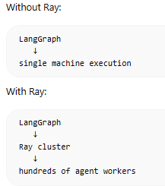
- Observability / debugging
  - Multi-agent systems break without monitoring
  - 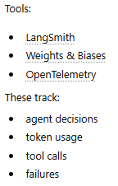

Example architecture for a serious multi-agent system
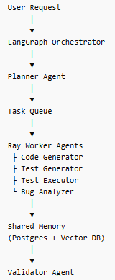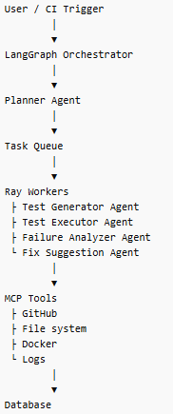

Combining LangGraph + AutoGen
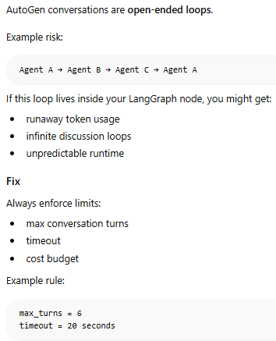
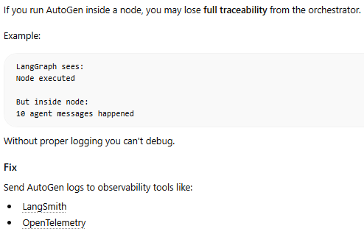

Celery
Celery is a distributed task queue used for running asynchronous background jobs.
👉 Think of it as:
- “Run this task later or in background”
- Simple, fast, widely used in Python

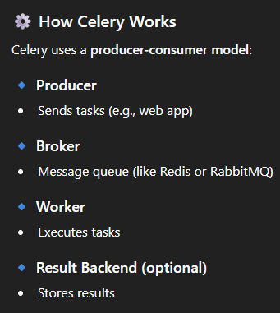

How to handle all types of database structures
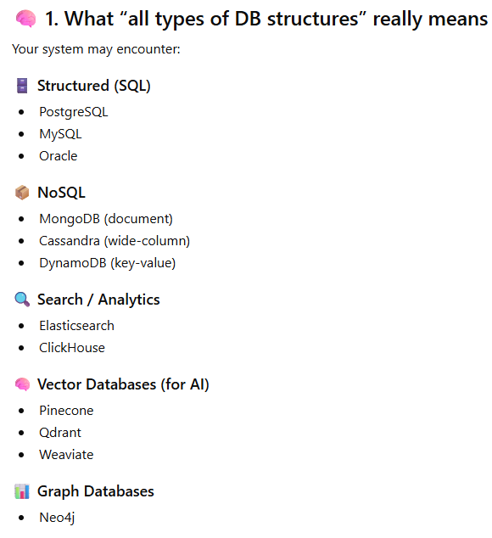

Solution :- DB Abstraction Layer( Using Adapters )
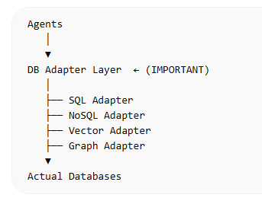

What exactly is an Adapter?
An adapter is a small piece of code that translates common instruction into a database-specific query.
👉 Think of it like:
- Input: simple, standard request
- Output: database-specific command

Adapter Structure
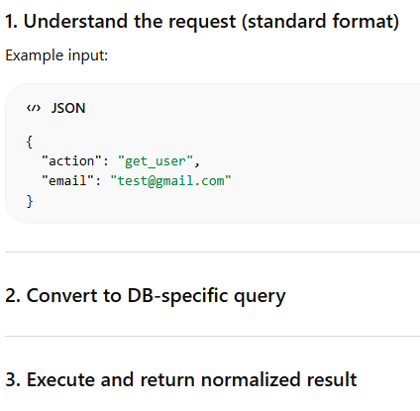

Internal Design of an Adapter
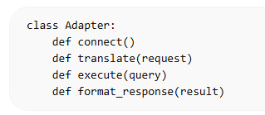

How does the system know whether to use SQL Adapter, Mongo Adapter, etc.?

Database Routing Layer (or DB Router)
It is a component in a software system, often at the application or middleware level, that directs client requests to the appropriate database instance or shard
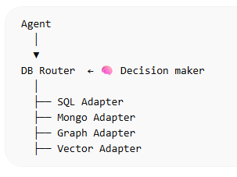

Machine Learning (ML)
Machine learning is a branch of AI that focuses on developing models and algorithms that let computers learn patterns from data instead of being explicitly programmed.

Input data Learn patterns Make predictions

Types :-

Supervised Learning
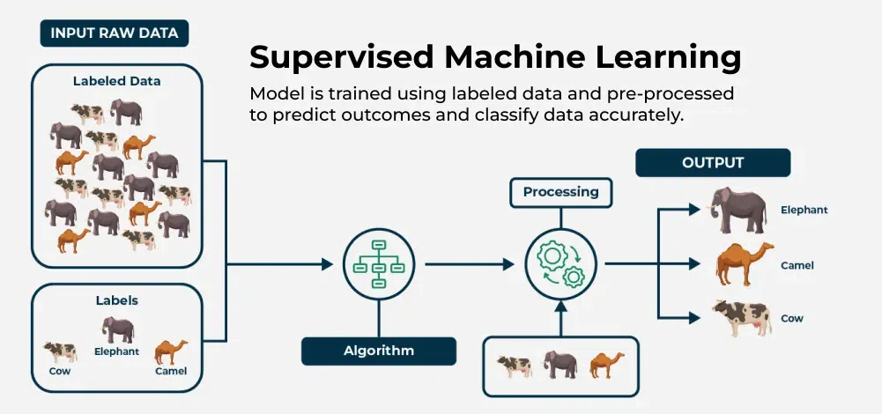

Its main features are:
- Labelled Data: Each input has a known output
- Learning from Errors: Adjusts itself to reduce prediction errors
- Goal: Make accurate predictions on new data
- Example: Recognizing handwritten digits from trained data

Types of Supervised Learning

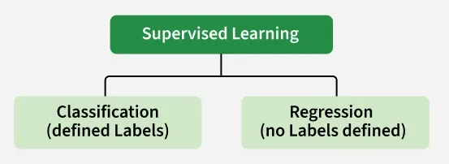

Classification (defined Labels)
Classification is used to predict labels or categories based on input data. The goal is to assign each data point to a predefined class, such as spam vs. non-spam emails or diseased vs. healthy patients.

Regression (no Labels defined)
Regression is used to predict continuous numerical values by learning relationships between input variables (features) and an output variable (target).

Algorithms used in Supervised Learning

1.Linear Regression
Used to predict continuous values.
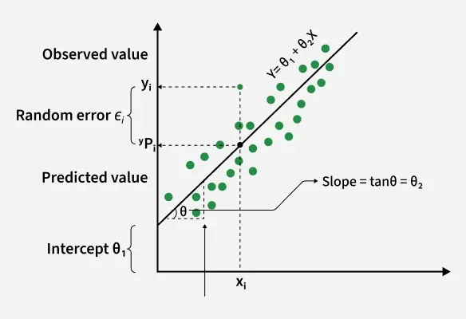
Equation of the Best-Fit Line
y= mx+b
Sum of squared errors (SSE) = y=mx+by=mx+b

2.Logistic Regression
Used for classification problems (not regression despite the name).
Examples:
- Spam vs Not Spam
- Disease: Yes / No
- Pass / Fail

How It Works
- Take input (X)
- Apply linear equation
- Pass result through Sigmoid function
- Get probability
- Convert to class (0 or 1)

Types:-

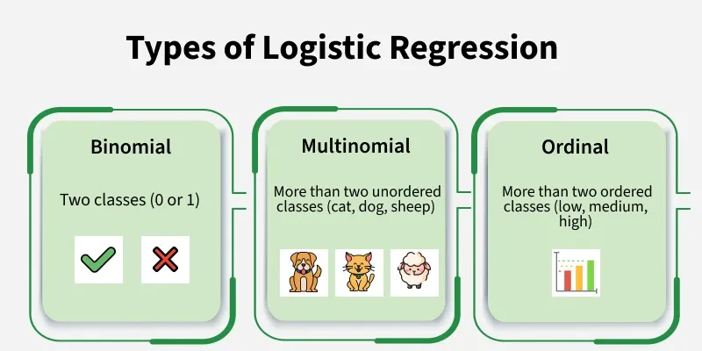

Binomial
Used when there are only 2 classes
- Example: Yes / No, Spam / Not Spam

Multinomial
Used when there are more than 2 classes (no order)
- Example: Cat / Dog / Bird

Ordinal
Used when there are more than 2 classes with order
- Example: Low / Medium / High

3.Decision Trees
A decision tree is a supervised learning algorithm used for both classification and regression tasks. It has a hierarchical tree structure which consists of a root node, branches, internal nodes and leaf nodes. It works like a flowchart that helps in making step by step decision, where:
- Internal nodes represent attribute tests
- Branches represent attribute values
- Leaf nodes represent final decisions or predictions.

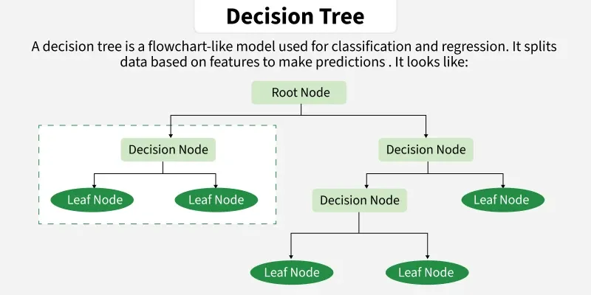

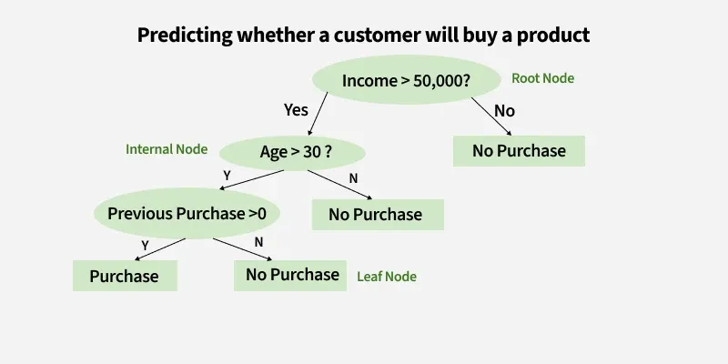

4.Support Vector machine (SVM)
Support Vector Machine (SVM) is a supervised machine learning algorithm used for classification and regression tasks. It tries to find the best boundary known as hyperplane that separates different classes in the data. It is useful when you want to do binary classification like spam vs. not spam or cat vs. dog.
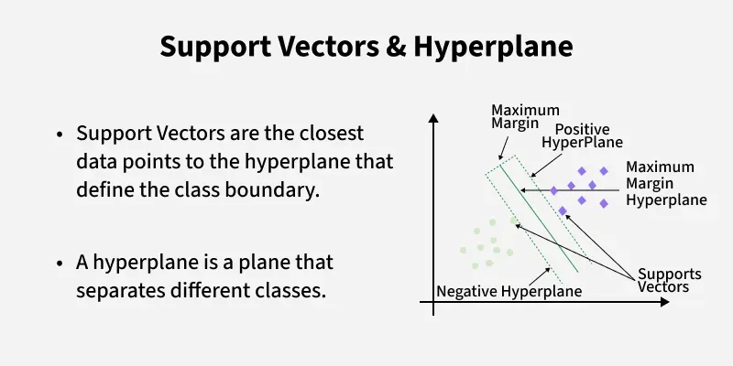

5.k-Nearest Neighbors (k-NN)
K-Nearest Neighbor is a simple and widely used machine learning technique for classification and regression tasks. It works by identifying the K closest data points to a given input and making predictions based on the majority class or average value of those neighbors.
- Classifies data based on similarity with nearby data points
- Uses distance metrics like Euclidean distance to find nearest neighbors
- Since KNN makes no assumptions about the underlying data distribution, it makes it a non-parametric and instance-based learning method.

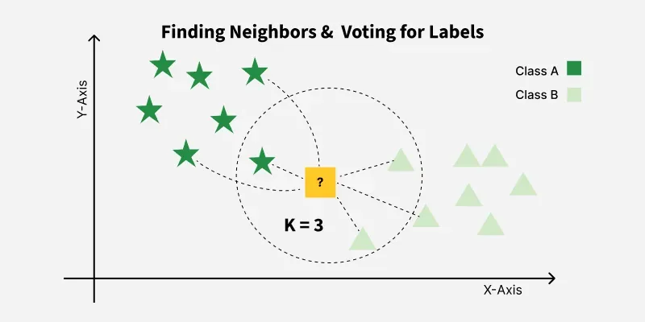

6.Naïve Bayes
Naïve Bayes is a algorithm used for classification.
It is based on probability – meaning it predicts the class that is most likely based on the input.
It is called:
- “Bayes” → because it uses Bayes’ Theorem
- “Naive” → because it naively assumes all features are independent (which is rarely true, but still works great!)

7.Random Forest (Bagging Algorithm)
Random Forest is a machine learning algorithm that uses a group of Decision Trees to make predictions.
A single decision tree can be unstable — small changes in data create very different trees.
Random Forest solves this by:
✔ Building many trees
✔ Each tree is trained on different random subsets of the data
✔ All trees vote → majority vote wins (classification)
✔ Average of predictions (regression)

Unsupervised learning
Unsupervised Learning where the model works without labelled data. It learns patterns on its own by grouping similar data points or finding hidden structures without any human intervention.
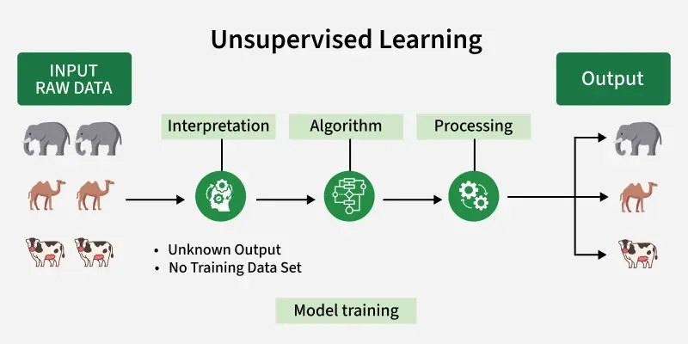

Working of Unsupervised Learning
1. Collect Unlabeled Data
2. Select an Algorithm
3. Train the Model on Raw Data
4. Group or Transform Data
5. Interpret and Use Results

Algorithm used in Unsupervised learning

Clustering
Clustering is a technique used to group similar data points together without using labelled data. It helps discover hidden patterns or natural groupings in datasets by placing similar data points into the same cluster.
- Discover the natural grouping or structure in unlabeled data without predefined categories.
- Data points are assigned to clusters based on similarity or distance measures.
- Uses Euclidean distance, cosine similarity or other metrics depending on data type and clustering method.
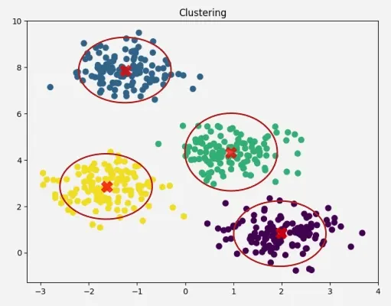

Association Rule Mining
Association Rule Mining discovers interesting relationships among items in large datasets.
Think of it as:
“If a customer buys X, they are likely to buy Y.”

Dimensionality Reduction
Reducing the number of input variables (features) but keeping the important patterns.
Simple Analogy
Imagine you have a huge suitcase filled with clothes.
But you only need:
- T-shirts
- Jeans
- Shoes
You remove unnecessary items to make the suitcase lighter.
Dimensionality reduction does the same thing with data.

Reinforcement learning
Reinforcement Learning (RL) focuses on how agents can learn to make decisions through trial and error to maximize cumulative rewards. RL allows machines to learn by interacting with an environment and receiving feedback based on their actions.
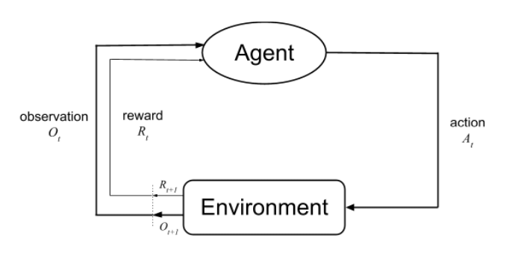
- Agent: The decision-maker that performs actions.
- Environment: The world or system in which the agent operates.
- State: The situation or condition the agent is currently in.
- Action: The possible moves or decisions the agent can make.
- Reward: The feedback or result from the environment based on the agent’s action.

Machine Learning Pipeline

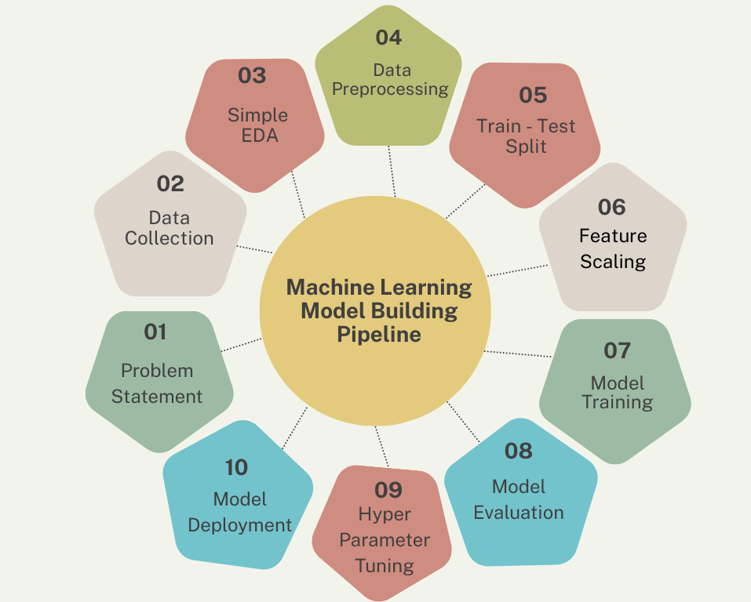

1.Problem Statement
Define the goal clearly
- What are you trying to solve?
- Example: Predict house prices / detect spam

2.Data Collection
Gather data relevant to the problem
- Databases, APIs, surveys, sensors
- Example: house prices dataset

3.Simple EDA (Exploratory Data Analysis)
Understand the data
- Check patterns
- Find outliers
- Look at distributions
Example:
- Are prices increasing?
- Any missing values?

4.Data Preprocessing
Clean and prepare data
- Handle missing values
- Remove duplicates
- Convert text → numbers
Make data usable for ML

5.Train-Test Split
Divide data
- Training set → model learns
- Test set → final evaluation
Never train on test data

6.Feature Scaling
Normalize data values
- Example: Age (1–100) vs Salary (1000–100000)
- Scaling makes them comparable
Methods:
- Normalization
- Standardization

7.Model Training
Teach the model
- Apply algorithms (Linear Regression, Decision Tree, etc.)
- Model learns patterns

8.Model Evaluation
Check performance
- Classification → Accuracy, Precision
- Regression → MSE, RMSE

9.Hyperparameter Tuning
Improve the model
- Adjust settings (not learned automatically)
- Example:
  - Learning rate
  - Tree depth
Make model more accurate

10.Model Deployment
Use the model in real world
- Website
- App
- API
Final goal: real-world usage

